Call for Applications

8-Scholarships

Research-Retreat
„Crossing Arts & Philosophy: COME ON!”
Performing mental, socio-political, environmental Ecologies (Felix Guattari)

Open for ALL Students of Angewandte, MUK, GMPUM, mdw

Mentors
em.o.Univ.Prof ^{in} Dr^{in} Susanne Valerie Granzer, Professor for Acting Max Reinhardt Seminar, University for Music and Performing Arts Vienna
Univ.Doz.Dr.habil. Arno Böhler, associate Professor for Philosophy, University of Vienna, Max Reinhardt Seminar mdw

Place
Performance Centre KHORA
baseCollective, Kehrbach 2, Lower Austria
(easy reachable from railway station Westbahnhof Vienna to Melk within one hour)

Duration
3 research labs between October-December 2022
Lab #1: Thursday, October 27, 3:pm – Saturday, October29, 7:pm
Lab #2: Thursday, November 3, 3:pm – Saturday, November 05, 7:pm
Lab #3: Thursday, December 01, 3:pm – Saturday, December 3, 7:pm

4 ECTS credits for angewandte, GMPUM, MUK, mdw students

„Crossing Arts & Philosophy: COME ON!”
If you are interested to enhance your artistic and scientific practice further in a close cross-disciplinary cooperation with philosophers, who are interested in arts-based-philosophy, this practice-based Research Retreat “Crossing Arts & Philosophy” will provide you the opportunity to develop new cross-disciplinary skills in your artistic practices.

The focus of our research retreat lies in a project-oriented cross-over of artistic & philosophical research practices: Art students will create––in a close co-operation with philosophy students of the University of Vienna––an intra-disciplinary field-performance, in which our research group will collectively stage the outcome of their research in the performance place KHORA. Susanne Valerie Granzer (actress) and Arno Böhler (philosopher) will guide you through the retreat. How the local people from the countryside can be involved into the “field-performance” should be considered seriously.

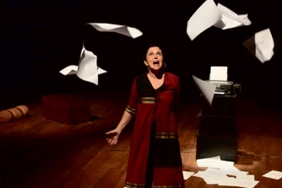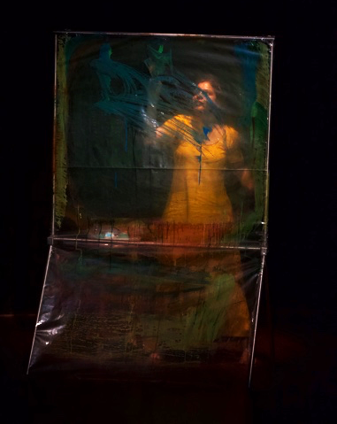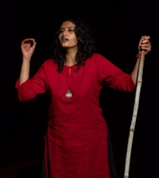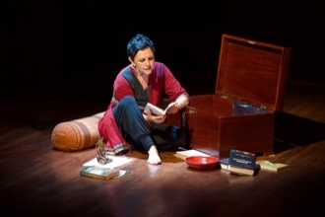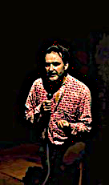
Impressions from our field-performance INSIDE / OUTSIDE created in the 1st Research-Retreat at the Performance Space KHORA in June 2022

Lab #1: The Art of Reading. The first gathering of our research group will take place from Thursday, October 27, 3pm - Saturday, October 29, 7pm. At first, we will read, analyse, comment and critically discuss Félix Guattari’s concept of “3 Ecologies,” in which he calls a mental (1), environmental (2) and socio-political (3) eco-revolution into being. The cross-over of art & philosophy thereby plays a crucial role to create a “memory of the future” for the sake of a mental, environmental and socio-political eco-future to come. (Guattari, Félix (1989): The 3 Ecologies. Trans. by Ian Pindar and Paul Sutton. The Athlone Press 2000; Böhler, Arno e.al. (Eds.) (2017): Philosophy On Stage. The Concept of Immanence in Contemporary Art and Philosophy. Performance Philosophy Journal, (Vol. 3/3); Spivak, Gayatri Ch. (2013): Aesthetic Education in the Era of Globalization, Harvard University Press. Ghose, Aurobindo (1914-1921): The Synthesis of Yoga, Pondicherry 1999.

Lab #2: The Art of Staging a Field. The second gathering will take place from Thursday, November 3, 3pm till Saturday, November 5, 7pm. Now it is time to condense the discussions from the first meeting and let them trigger artistic stimuli. Thus, the focus switches from the discursive level to the artistic animation. It is anima, the artistic “soul,” that is called to show up and articulate itself artistically on stage during this second gathering.

Lab #3: The Art of Mattering. In our third and final meeting our cross-disciplinary research group will orchestrate an intra-disciplinary “field-performance,” which finally will be staged in the performance-center KHORA by the artists and philosophers, who are part of our research-retreat. (December 1st till December 3rd 2022)

APPLICATIONS

Each scholarship covers the entire costs of the retreat programme, namely:
- Collective transfer of all group-members from railway station Pöchlarn to the Retreat-Centre KHORA
- Accommodation in a double room, shared with another member of our research retreat
- Breakfast, snacks, dinner
- The compensation for the directors of the programme, Arno Böhler and Susanne Valerie Granzer

Applications for a scholarship “Research Retreat: Crossing Arts & Philosophy: The Three Ecologies”:
please send your application via e-mail to: arno.boehler@univie.ac.at (deadline: September 15, 2022).

Application credentials:
- Personal statement on motivation (half page up to one page)
- CV incl. list of publications and/or catalogue of works/raisonné (max 2 pages)

In the second half of September 2022 our artistic-scientific advisory board will decide about the applications. You will be informed about the decision before October 1st, 2022.

………………………………………………………………………………………………………………………………………………………………………………
WHO IS baseCollective?

baseCollective is an intra-disciplinary research group for artistic research and arts-based philosophy located in Vienna (Austria). It has been founded by Arno Böhler and Susanne Valerie Granzer. Arno Böhler teaches at the University of Vienna, Department of Philosophy (faculty member) and at mdw, Max Reinhardt Seminar. Susanne Valerie Granzer is an actress and professor emeritus for acting at mdw, Max Reinhardt Seminar, teaching Aesthetics there right now. Böhler and Granzer have developed the format of Philosophy On Stage over the last 20 years, which meanwhile became an internationally recognized role model for artistic-research and arts-based philosophy. See: Philosophy On Stage: https://homepage.univie.ac.at/arno.boehler/php/?page_id=841

Field-Performances create an artistic space, shaped on one hand by the artistic contributions, and, on the other hand, by the audience, visiting the field. The audience is called not just to look at the contributions, but to become aware of the way, how it inhabits the performance-field itself.
If a member of our research group insists to have a single room, the upgrade for the single room has to be paid by the researcher him/herself.

